Project Report

Student Management System
Submitted in partial fulfilment of the requirement
for Subject of RDBMS (CC2002)
BACHELOR OF TECHNOLOGY (B.Tech)
in Computer and Communication Engineering
By Aaditya Gupta 199303129 and
Sidharth Gautam 199303054,

Under the guidance of
Dr. Geeta Rani

Department of Computer and Communication
Engineering School of Computing and Information Technology
Manipal University Jaipur
Jaipur, Rajasthan

Introduction
A student database management system is modernization of manual record management system which enables the users to assess important academic data via the internet from any location and at any time. Teachers can view and manage data like student’s personal data, course, attendance etc., while students can view their personal and academic data like their attendance, course, faculty etc. It provides facilities like addition and deletion of student data thus reducing paperwork and automating the record generation process in an educational institution.
It’ll also facilitate keeping all the records of students, such as their id, name, mailing address, phone number, DOB, etc. So all the information about a student will be available in a few seconds. It’ll make Student Information Management an easier job for the administrator and the student of any organization.
Till today most of the educational institutions around the country take attendance manually, it is very time consuming and costly process. Development of this application is highly economically feasible and it is helpful for students as well as the school/college authorities. Achieving this objective is difficult using the manual system as the information is scattered, can be redundant and collecting relevant information may be very time-consuming.
Our proposed system has several advantages:
- User friendly interface
- Fast access and modification to database
- Less error, less data redundancy
- Less paperwork
- More Storage Capacity, Data Backup
- Better and Quick Search facility
Motivation- The motivation for doing this project was primarily an interest in the working of relational database. The opportunity to learn about database while practically implementing it in a web based application, looked like a great challenge in the beginning for us. Also, our faculty mentor Dr. Geeta Rani encouraged us to do this project that we’re interested in and would only enhance our learning of the Rdbms , which gave us this opportunity to explore in the area of database creation, management and web application implementation . We believe this system should be implemented in all schools and colleges around the country and a lot of paper and time can be saved by this system.

Tables Made –
- Attendance
- Student
- Faculty
- Course
- Student_Faculty
- Student_Course .

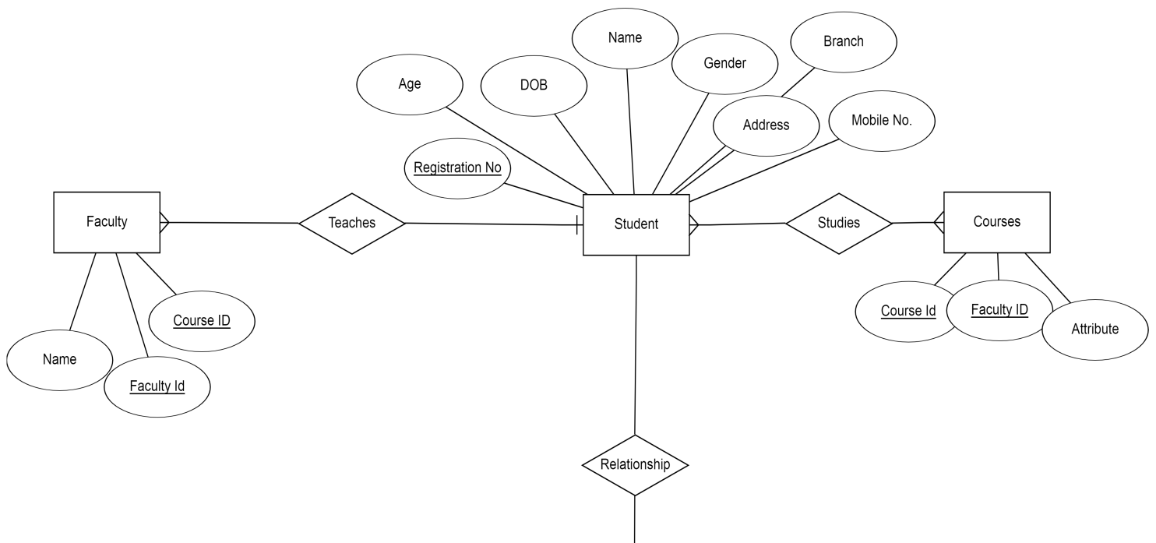


ER Diagram

Screenshots
Home Page 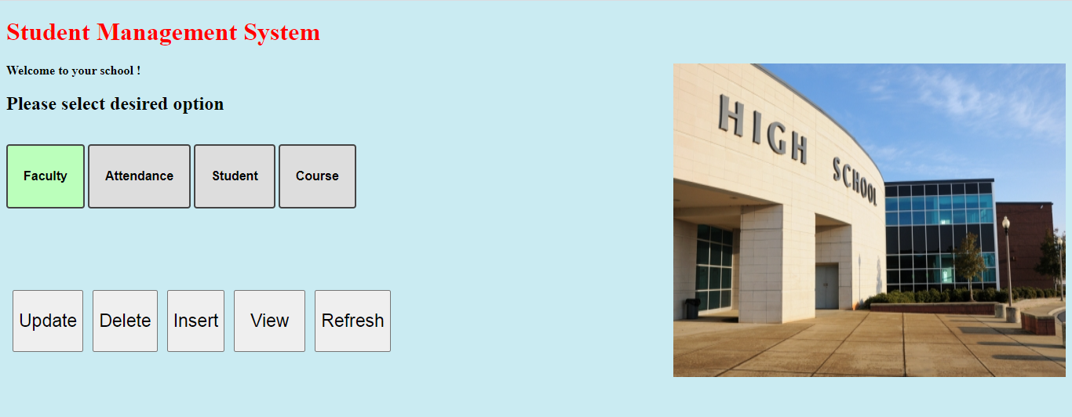
Add Attendance page 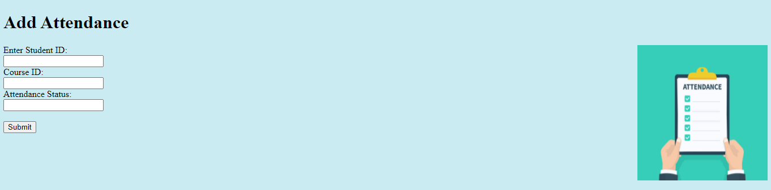
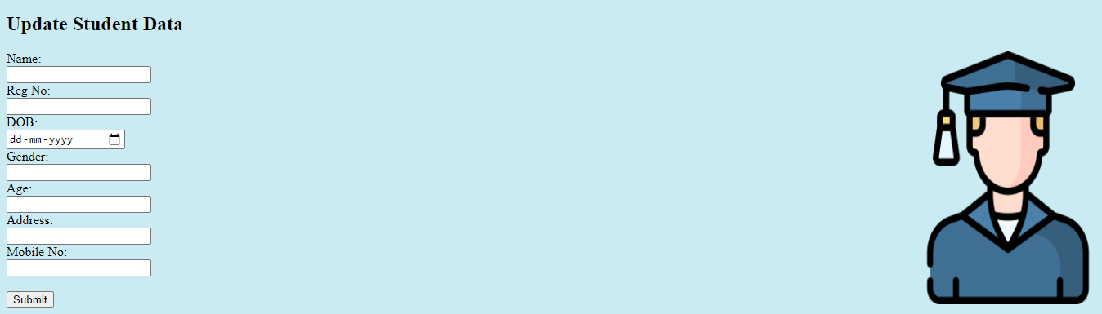

Methodology
- Research - on how to create a web application with backend and static data website and setting it up with a local server to fetch data from API , where the API’s return result of database queries and modifications.

- Website Design- Learning Html and polishing our skills in it to make a user friendly design of webpages with good quality code thus creating a website that is equally good in performance as well as aesthetics.
- Database design- Making of ER diagram for visualization of data, Deciding the structure and making of schema of our database to act as the foundation, Learning about relational database and usage and its various features.

- Database Implementation- Learning SQL and making use of it in creating tables and columns, assigning primary keys, connecting foreign keys for smooth working of database, Inserting data and query optimization, finalizing Crud(create,read,update,delete) operation queries for seamless working by the MySql Workbench .

- WebPage Finalization- Learning and using Javascript to connect different webpages and to finalize the front end part of the system.

- Website Implementation- Learing PHP, basic understanding of the language and using php scripts to add functionality to return result of actions to website from database and go back and forth via PhpMyAdmin, Adding the interactivity to the website which was the most difficult part, connecting the buttons and webpages and UI by javascript, selecting two buttons simultaneously were one the big challenges that we faced during the implementation.

- Setting of XAMPP which is a lightweight software solution to create local web host for the app, it helps in setting up and completion of intricate design and functionality of the system.

- Testing and giving final touch-up to the website, this involves debugging the errors encountered after the system functions as a whole.
Software Requirements
Web Browser- Google Chrome, Mozilla Firefox
PhpMyAdmin ,
MySql Wrokbench , XAMPP
Windows 10 Operating System
Programming Language Used : Frontend- HTML, Javascript ,
Backend- SQL, PHP.
Hardware Requirements
Microprocessor: Intel(R) Core(TM) i5-3230M
CPU @ 2.3 GHz
RAM: 4 GB of RAM
Hard Disk: 500 Gigabytes (GB)
Internet Connectivity .
Applications-
- Educational institutions to maintain their student records safely and easily.
- It can be used to take day to day attendance and automatically send an SMS to the Defaulters who have less attendance.
- The web app enables its users to access, manage and update his/her data effectively and efficiently, also improves transparency.
- It allows for a centralized facility that can easily be modified and quickly shared within seconds.
- In Future more functions can be added like Marks, Report Card, Assignment even linking the Hostel facilities would be possible though it would require time and resources for development of a system of this size.
- It practically eliminates the paper work which could lead to loss of data and data redundancy.

Conclusion - The web application is designed for basic purpose for maintaining student data like –personal data, course, attendance and faculty data in a dynamic manner. It is programmed using simple and vivid code .The use of highly user friendly software PhpMyAdmin for accessing the database and MySQL workbench for development of database. The web app uses the following for enhancing its look and functionality Hypertext markup language(HTML) used for building web pages and styling and JavaScript’s used for programming the web pages script for development of User interface, connecting of webpages etc, both languages helps in designing the portal with ease and in desired manner. XAMPP helps in bringing all these stages of development into one and thus enables the functioning of the system as a whole.
The web app enables its users to access, manage and update his/her data effectively and efficiently. Having a web based front end removes the requirement of users having to understand and use a database directly, and allows users to connect from anywhere with an internet connection and a basic web browser. It's an excellent application as it ensure data integrity, privacy, and security in department. Although all the objectives have been met, the system still has room for improvement. The system is robust and ﬂexible for new upgrade in functionality and features in near future.

